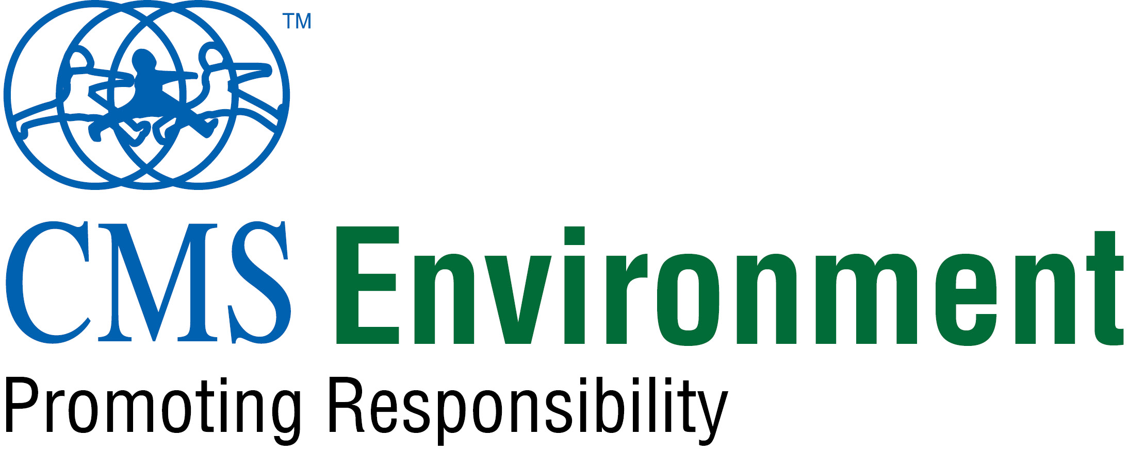
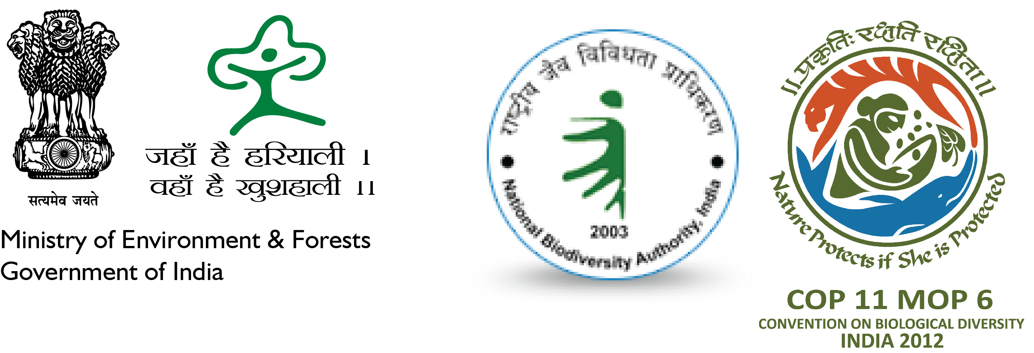

For immediate release

Hyderabad CMS VATAVARAN
International Biodiversity Film Festival and Forum
October 9 – 19, 2012

Hyderabad: Oct 9, 2012: CMS Environment in association with Ministry of Environment and Forests, Govt of India and National Biodiversity Authority, India is hosting International Biodiversity Film Festival and Forum in Hyderabad as part of COP-11 to the Convention on Biological Diversity from Oct 09 – 19, 2012. The festival will include screening of 42 best of Indian and international films on biodiversity issues and COP-11 agenda for the festival delegates.

The festival will be inaugurated by senior officials from Ministry of Environment and Forests, Govt of India and Dr Balakrishna Pisupati, Chairman of National Biodiversity Authority, India on Oct 09, 2012 from 06:00 pm to 07:00 pm at Hall 2, HITEX, Hyderabad.

The films being shown in this festival are internationally acclaimed films representing different countries across the globe i.e. India, China, France, Finland, Germany, Japan, Netherlands, Taiwan, UK and USA. The best award-winning films from international and eminent film festivals such Ya’an Panda International Animal & Nature Film Festival, Germany; Jackson Hole International Film Festival, USA; Wildlife Vasa Festival, Finland and Animal Festival, China besides CMS VATAVARAN will be shown in this festival.

Diverse floral and faunal species, their behaviour, importance and inter-linkage with mankind is also being highlighted through the medium of films. The various species focused through this festival are: neem, vultures, red pandas, reptiles and amphibians, tiger, birds, sharks, butterflies, cuttlefish, polar bears, crocodiles, lion, etc. Diverse ecosystems such as Loktak lake in north-eastern India, Amazon river, Arctic Pole, etc are also highlighted through the films. Each film to be screened in this festival is not only good to see, but is also good to think about.

The films will be screened at different venues of COP-11 such as CEPA Fair, Hyderabad International Exhibition Centre (HICC); Seminar Hall, PG Block, National Academy of Constructions (NAC) campus and Food Court, Hall No 3, HICC.

About CMS Environment
The CMS Environment Team has been involved multifariously in policy research and programmes evaluation aimed at creating sustainable solutions for environment protection. The team’s thematic focus is on climate change, low carbon practices, biodiversity conservation, drinking water and sanitation and livelihoods. India’s premier film festival on environment and wildlife, CMS VATAVARAN is also an initiative (started in 2002) of the eclectic CMS Environment team. This year besides Hyderabad, Dehradun, Jaipur and Goa are the other cities where the biodiversity film festival and forum has been hosted.

For more information contact:
Priya Verma, Festival Coordinator, CMS Environment,
M +91 98999 79165 | Tel +91 11 2652 2244/55;
E: priya@cmsindia.org; info@cmsvatavaran.org | www.cmsvatavaran.org

